The data set used this paper are published by the whatever it is

The data is relative to the canadian housing reslate data from 2007 to 2023, by using this data, we could futhury sytudent waht is going on Canadian housing makret.

This paper is fousing on study how canadian housing market will respond to thepolicy rate change if Bank of Canadian remine the policy rate high as 4.5%.

Author using the housing reslce data m and ther avalidalt macro data to consturion one ARIMA model and VAR model to conditional forecast if canaidna hosuing go over 45.

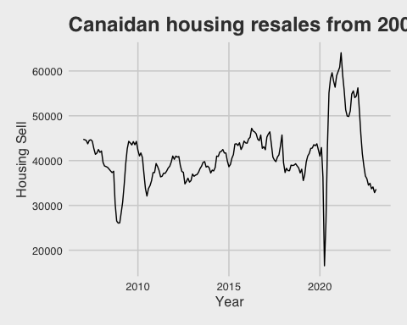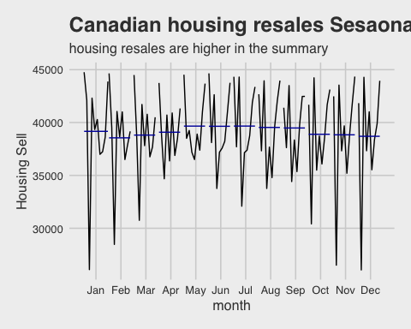

## List of 99  
## $ line :List of 6  
## ..$ colour : chr "black"  
## ..$ linewidth : num 0.545  
## ..$ linetype : num 1  
## ..$ lineend : chr "butt"  
## ..$ arrow : logi FALSE  
## ..$ inherit.blank: logi FALSE  
## ..- attr(*, "class")= chr [1:2] "element_line" "element"  
## $ rect :List of 5  
## ..$ fill : Named chr "#F0F0F0"  
## .. ..- attr(*, "names")= chr "Light Gray"  
## ..$ colour : logi NA  
## ..$ linewidth : num 0.545  
## ..$ linetype : num 0  
## ..$ inherit.blank: logi FALSE  
## ..- attr(*, "class")= chr [1:2] "element_rect" "element"  
## $ text :List of 11  
## ..$ family : chr "sans"  
## ..$ face : chr "plain"  
## ..$ colour : Named chr "#3C3C3C"  
## .. ..- attr(*, "names")= chr "Dark Gray"  
## ..$ size : num 12  
## ..$ hjust : num 0.5  
## ..$ vjust : num 0.5  
## ..$ angle : num 0  
## ..$ lineheight : num 0.9  
## ..$ margin : 'margin' num [1:4] 0points 0points 0points 0points  
## .. ..- attr(*, "unit")= int 8  
## ..$ debug : logi FALSE  
## ..$ inherit.blank: logi FALSE  
## ..- attr(*, "class")= chr [1:2] "element_text" "element"  
## $ title : chr "Canadian norminal GDP growth rate (2002 = 100)"  
## $ aspect.ratio : NULL  
## $ axis.title :List of 11  
## ..$ family : NULL  
## ..$ face : NULL  
## ..$ colour : NULL  
## ..$ size : NULL  
## ..$ hjust : NULL  
## ..$ vjust : NULL  
## ..$ angle : NULL  
## ..$ lineheight : NULL  
## ..$ margin : NULL  
## ..$ debug : NULL  
## ..$ inherit.blank: logi FALSE  
## ..- attr(*, "class")= chr [1:2] "element_text" "element"  
## $ axis.title.x :List of 11  
## ..$ family : NULL  
## ..$ face : NULL  
## ..$ colour : NULL  
## ..$ size : NULL  
## ..$ hjust : NULL  
## ..$ vjust : num 1  
## ..$ angle : NULL  
## ..$ lineheight : NULL  
## ..$ margin : 'margin' num [1:4] 3points 0points 0points 0points  
## .. ..- attr(*, "unit")= int 8  
## ..$ debug : NULL  
## ..$ inherit.blank: logi TRUE  
## ..- attr(*, "class")= chr [1:2] "element_text" "element"  
## $ axis.title.x.top :List of 11  
## ..$ family : NULL  
## ..$ face : NULL  
## ..$ colour : NULL  
## ..$ size : NULL  
## ..$ hjust : NULL  
## ..$ vjust : num 0  
## ..$ angle : NULL  
## ..$ lineheight : NULL  
## ..$ margin : 'margin' num [1:4] 0points 0points 3points 0points  
## .. ..- attr(*, "unit")= int 8  
## ..$ debug : NULL  
## ..$ inherit.blank: logi TRUE  
## ..- attr(*, "class")= chr [1:2] "element_text" "element"  
## $ axis.title.x.bottom : NULL  
## $ axis.title.y :List of 11  
## ..$ family : NULL  
## ..$ face : NULL  
## ..$ colour : NULL  
## ..$ size : NULL  
## ..$ hjust : NULL  
## ..$ vjust : num 1  
## ..$ angle : num 90  
## ..$ lineheight : NULL  
## ..$ margin : 'margin' num [1:4] 0points 3points 0points 0points  
## .. ..- attr(*, "unit")= int 8  
## ..$ debug : NULL  
## ..$ inherit.blank: logi TRUE  
## ..- attr(*, "class")= chr [1:2] "element_text" "element"  
## $ axis.title.y.left : NULL  
## $ axis.title.y.right :List of 11  
## ..$ family : NULL  
## ..$ face : NULL  
## ..$ colour : NULL  
## ..$ size : NULL  
## ..$ hjust : NULL  
## ..$ vjust : num 0  
## ..$ angle : num -90  
## ..$ lineheight : NULL  
## ..$ margin : 'margin' num [1:4] 0points 0points 0points 3points  
## .. ..- attr(*, "unit")= int 8  
## ..$ debug : NULL  
## ..$ inherit.blank: logi TRUE  
## ..- attr(*, "class")= chr [1:2] "element_text" "element"  
## $ axis.text :List of 11  
## ..$ family : NULL  
## ..$ face : NULL  
## ..$ colour : NULL  
## ..$ size : 'rel' num 0.8  
## ..$ hjust : NULL  
## ..$ vjust : NULL  
## ..$ angle : NULL  
## ..$ lineheight : NULL  
## ..$ margin : NULL  
## ..$ debug : NULL  
## ..$ inherit.blank: logi FALSE  
## ..- attr(*, "class")= chr [1:2] "element_text" "element"  
## $ axis.text.x :List of 11  
## ..$ family : NULL  
## ..$ face : NULL  
## ..$ colour : NULL  
## ..$ size : NULL  
## ..$ hjust : NULL  
## ..$ vjust : num 1  
## ..$ angle : NULL  
## ..$ lineheight : NULL  
## ..$ margin : 'margin' num [1:4] 2.4points 0points 0points 0points  
## .. ..- attr(*, "unit")= int 8  
## ..$ debug : NULL  
## ..$ inherit.blank: logi TRUE  
## ..- attr(*, "class")= chr [1:2] "element_text" "element"  
## $ axis.text.x.top :List of 11  
## ..$ family : NULL  
## ..$ face : NULL  
## ..$ colour : NULL  
## ..$ size : NULL  
## ..$ hjust : NULL  
## ..$ vjust : num 0  
## ..$ angle : NULL  
## ..$ lineheight : NULL  
## ..$ margin : 'margin' num [1:4] 0points 0points 2.4points 0points  
## .. ..- attr(*, "unit")= int 8  
## ..$ debug : NULL  
## ..$ inherit.blank: logi TRUE  
## ..- attr(*, "class")= chr [1:2] "element_text" "element"  
## $ axis.text.x.bottom : NULL  
## $ axis.text.y :List of 11  
## ..$ family : NULL  
## ..$ face : NULL  
## ..$ colour : NULL  
## ..$ size : NULL  
## ..$ hjust : num 1  
## ..$ vjust : NULL  
## ..$ angle : NULL  
## ..$ lineheight : NULL  
## ..$ margin : 'margin' num [1:4] 0points 2.4points 0points 0points  
## .. ..- attr(*, "unit")= int 8  
## ..$ debug : NULL  
## ..$ inherit.blank: logi TRUE  
## ..- attr(*, "class")= chr [1:2] "element_text" "element"  
## $ axis.text.y.left : NULL  
## $ axis.text.y.right :List of 11  
## ..$ family : NULL  
## ..$ face : NULL  
## ..$ colour : NULL  
## ..$ size : NULL  
## ..$ hjust : num 0  
## ..$ vjust : NULL  
## ..$ angle : NULL  
## ..$ lineheight : NULL  
## ..$ margin : 'margin' num [1:4] 0points 0points 0points 2.4points  
## .. ..- attr(*, "unit")= int 8  
## ..$ debug : NULL  
## ..$ inherit.blank: logi TRUE  
## ..- attr(*, "class")= chr [1:2] "element_text" "element"  
## $ axis.ticks : list()  
## ..- attr(*, "class")= chr [1:2] "element_blank" "element"  
## $ axis.ticks.x : NULL  
## $ axis.ticks.x.top : NULL  
## $ axis.ticks.x.bottom : NULL  
## $ axis.ticks.y : NULL  
## $ axis.ticks.y.left : NULL  
## $ axis.ticks.y.right : NULL  
## $ axis.ticks.length : 'simpleUnit' num 3points  
## ..- attr(*, "unit")= int 8  
## $ axis.ticks.length.x : NULL  
## $ axis.ticks.length.x.top : NULL  
## $ axis.ticks.length.x.bottom: NULL  
## $ axis.ticks.length.y : NULL  
## $ axis.ticks.length.y.left : NULL  
## $ axis.ticks.length.y.right : NULL  
## $ axis.line : list()  
## ..- attr(*, "class")= chr [1:2] "element_blank" "element"  
## $ axis.line.x : NULL  
## $ axis.line.x.top : NULL  
## $ axis.line.x.bottom : NULL  
## $ axis.line.y : NULL  
## $ axis.line.y.left : NULL  
## $ axis.line.y.right : NULL  
## $ legend.background :List of 5  
## ..$ fill : NULL  
## ..$ colour : logi NA  
## ..$ linewidth : NULL  
## ..$ linetype : NULL  
## ..$ inherit.blank: logi FALSE  
## ..- attr(*, "class")= chr [1:2] "element_rect" "element"  
## $ legend.margin : 'margin' num [1:4] 6points 6points 6points 6points  
## ..- attr(*, "unit")= int 8  
## $ legend.spacing : 'simpleUnit' num 12points  
## ..- attr(*, "unit")= int 8  
## $ legend.spacing.x : NULL  
## $ legend.spacing.y : NULL  
## $ legend.key :List of 5  
## ..$ fill : NULL  
## ..$ colour : NULL  
## ..$ linewidth : NULL  
## ..$ linetype : NULL  
## ..$ inherit.blank: logi TRUE  
## ..- attr(*, "class")= chr [1:2] "element_rect" "element"  
## $ legend.key.size : 'simpleUnit' num 1.2lines  
## ..- attr(*, "unit")= int 3  
## $ legend.key.height : NULL  
## $ legend.key.width : NULL  
## $ legend.text :List of 11  
## ..$ family : NULL  
## ..$ face : NULL  
## ..$ colour : NULL  
## ..$ size : 'rel' num 0.8  
## ..$ hjust : NULL  
## ..$ vjust : NULL  
## ..$ angle : NULL  
## ..$ lineheight : NULL  
## ..$ margin : NULL  
## ..$ debug : NULL  
## ..$ inherit.blank: logi TRUE  
## ..- attr(*, "class")= chr [1:2] "element_text" "element"  
## $ legend.text.align : NULL  
## $ legend.title :List of 11  
## ..$ family : NULL  
## ..$ face : NULL  
## ..$ colour : NULL  
## ..$ size : NULL  
## ..$ hjust : num 0  
## ..$ vjust : NULL  
## ..$ angle : NULL  
## ..$ lineheight : NULL  
## ..$ margin : NULL  
## ..$ debug : NULL  
## ..$ inherit.blank: logi TRUE  
## ..- attr(*, "class")= chr [1:2] "element_text" "element"  
## $ legend.title.align : NULL  
## $ legend.position : chr "bottom"  
## $ legend.direction : chr "horizontal"  
## $ legend.justification : chr "center"  
## $ legend.box : chr "vertical"  
## $ legend.box.just : NULL  
## $ legend.box.margin : 'margin' num [1:4] 0cm 0cm 0cm 0cm  
## ..- attr(*, "unit")= int 1  
## $ legend.box.background : list()  
## ..- attr(*, "class")= chr [1:2] "element_blank" "element"  
## $ legend.box.spacing : 'simpleUnit' num 12points  
## ..- attr(*, "unit")= int 8  
## $ panel.background :List of 5  
## ..$ fill : NULL  
## ..$ colour : NULL  
## ..$ linewidth : NULL  
## ..$ linetype : NULL  
## ..$ inherit.blank: logi TRUE  
## ..- attr(*, "class")= chr [1:2] "element_rect" "element"  
## $ panel.border :List of 5  
## ..$ fill : logi NA  
## ..$ colour : NULL  
## ..$ linewidth : NULL  
## ..$ linetype : NULL  
## ..$ inherit.blank: logi FALSE  
## ..- attr(*, "class")= chr [1:2] "element_rect" "element"  
## $ panel.spacing : 'simpleUnit' num 6points  
## ..- attr(*, "unit")= int 8  
## $ panel.spacing.x : NULL  
## $ panel.spacing.y : NULL  
## $ panel.grid :List of 6  
## ..$ colour : NULL  
## ..$ linewidth : NULL  
## ..$ linetype : NULL  
## ..$ lineend : NULL  
## ..$ arrow : logi FALSE  
## ..$ inherit.blank: logi FALSE  
## ..- attr(*, "class")= chr [1:2] "element_line" "element"  
## $ panel.grid.major :List of 6  
## ..$ colour : Named chr "#D2D2D2"  
## .. ..- attr(*, "names")= chr "Medium Gray"  
## ..$ linewidth : NULL  
## ..$ linetype : NULL  
## ..$ lineend : NULL  
## ..$ arrow : logi FALSE  
## ..$ inherit.blank: logi FALSE  
## ..- attr(*, "class")= chr [1:2] "element_line" "element"  
## $ panel.grid.minor : list()  
## ..- attr(*, "class")= chr [1:2] "element_blank" "element"  
## $ panel.grid.major.x : NULL  
## $ panel.grid.major.y : NULL  
## $ panel.grid.minor.x : NULL  
## $ panel.grid.minor.y : NULL  
## $ panel.ontop : logi FALSE  
## $ plot.background :List of 5  
## ..$ fill : NULL  
## ..$ colour : NULL  
## ..$ linewidth : NULL  
## ..$ linetype : NULL  
## ..$ inherit.blank: logi TRUE  
## ..- attr(*, "class")= chr [1:2] "element_rect" "element"  
## $ plot.title :List of 11  
## ..$ family : NULL  
## ..$ face : chr "bold"  
## ..$ colour : NULL  
## ..$ size : 'rel' num 1.5  
## ..$ hjust : num 0  
## ..$ vjust : num 1  
## ..$ angle : NULL  
## ..$ lineheight : NULL  
## ..$ margin : 'margin' num [1:4] 0points 0points 6points 0points  
## .. ..- attr(*, "unit")= int 8  
## ..$ debug : NULL  
## ..$ inherit.blank: logi FALSE  
## ..- attr(*, "class")= chr [1:2] "element_text" "element"  
## $ plot.title.position : chr "panel"  
## $ plot.subtitle :List of 11  
## ..$ family : NULL  
## ..$ face : NULL  
## ..$ colour : NULL  
## ..$ size : NULL  
## ..$ hjust : num 0  
## ..$ vjust : num 1  
## ..$ angle : NULL  
## ..$ lineheight : NULL  
## ..$ margin : 'margin' num [1:4] 0points 0points 6points 0points  
## .. ..- attr(*, "unit")= int 8  
## ..$ debug : NULL  
## ..$ inherit.blank: logi TRUE  
## ..- attr(*, "class")= chr [1:2] "element_text" "element"  
## $ plot.caption :List of 11  
## ..$ family : NULL  
## ..$ face : NULL  
## ..$ colour : NULL  
## ..$ size : 'rel' num 0.8  
## ..$ hjust : num 1  
## ..$ vjust : num 1  
## ..$ angle : NULL  
## ..$ lineheight : NULL  
## ..$ margin : 'margin' num [1:4] 6points 0points 0points 0points  
## .. ..- attr(*, "unit")= int 8  
## ..$ debug : NULL  
## ..$ inherit.blank: logi TRUE  
## ..- attr(*, "class")= chr [1:2] "element_text" "element"  
## $ plot.caption.position : chr "panel"  
## $ plot.tag :List of 11  
## ..$ family : NULL  
## ..$ face : NULL  
## ..$ colour : NULL  
## ..$ size : 'rel' num 1.2  
## ..$ hjust : num 0.5  
## ..$ vjust : num 0.5  
## ..$ angle : NULL  
## ..$ lineheight : NULL  
## ..$ margin : NULL  
## ..$ debug : NULL  
## ..$ inherit.blank: logi TRUE  
## ..- attr(*, "class")= chr [1:2] "element_text" "element"  
## $ plot.tag.position : chr "topleft"  
## $ plot.margin : 'simpleUnit' num [1:4] 1lines 1lines 1lines 1lines  
## ..- attr(*, "unit")= int 3  
## $ strip.background :List of 5  
## ..$ fill : NULL  
## ..$ colour : NULL  
## ..$ linewidth : NULL  
## ..$ linetype : NULL  
## ..$ inherit.blank: logi FALSE  
## ..- attr(*, "class")= chr [1:2] "element_rect" "element"  
## $ strip.background.x : NULL  
## $ strip.background.y : NULL  
## $ strip.clip : chr "inherit"  
## $ strip.placement : chr "inside"  
## $ strip.text :List of 11  
## ..$ family : NULL  
## ..$ face : NULL  
## ..$ colour : NULL  
## ..$ size : 'rel' num 0.8  
## ..$ hjust : NULL  
## ..$ vjust : NULL  
## ..$ angle : NULL  
## ..$ lineheight : NULL  
## ..$ margin : 'margin' num [1:4] 4.8points 4.8points 4.8points 4.8points  
## .. ..- attr(*, "unit")= int 8  
## ..$ debug : NULL  
## ..$ inherit.blank: logi TRUE  
## ..- attr(*, "class")= chr [1:2] "element_text" "element"  
## $ strip.text.x : NULL  
## $ strip.text.x.bottom : NULL  
## $ strip.text.x.top : NULL  
## $ strip.text.y :List of 11  
## ..$ family : NULL  
## ..$ face : NULL  
## ..$ colour : NULL  
## ..$ size : NULL  
## ..$ hjust : NULL  
## ..$ vjust : NULL  
## ..$ angle : num -90  
## ..$ lineheight : NULL  
## ..$ margin : NULL  
## ..$ debug : NULL  
## ..$ inherit.blank: logi TRUE  
## ..- attr(*, "class")= chr [1:2] "element_text" "element"  
## $ strip.text.y.left :List of 11  
## ..$ family : NULL  
## ..$ face : NULL  
## ..$ colour : NULL  
## ..$ size : NULL  
## ..$ hjust : NULL  
## ..$ vjust : NULL  
## ..$ angle : num 90  
## ..$ lineheight : NULL  
## ..$ margin : NULL  
## ..$ debug : NULL  
## ..$ inherit.blank: logi TRUE  
## ..- attr(*, "class")= chr [1:2] "element_text" "element"  
## $ strip.text.y.right : NULL  
## $ strip.switch.pad.grid : 'simpleUnit' num 3points  
## ..- attr(*, "unit")= int 8  
## $ strip.switch.pad.wrap : 'simpleUnit' num 3points  
## ..- attr(*, "unit")= int 8  
## $ x : chr "Year"  
## $ y : chr "percentage"  
## - attr(*, "class")= chr [1:2] "theme" "gg"  
## - attr(*, "complete")= logi TRUE  
## - attr(*, "validate")= logi TRUE

As shown in this graph, we can easily identify the trend of housing with the business cycle. The first drop can be explained as the dramatic impact of the 2008 financial crisis on the housing market. Another significant jump occurred around the beginning of 2020, when the first COVID-19 case was discovered in Canada, and COVID-19 became a global pandemic. Furthermore, as COVID-19 cases increased, the Canadian federal and provincial governments implemented COVID-19 restrictions to curb the spread, and the Bank of Canada lowered its policy rate to support the Canadian economy. As a result, there was a significant spike in housing sales. However, once the COVID-19 situation began to improve, and the war in Korea pushed up global energy prices, inflation in Canada reached an 8% 40-year high, resulting in a rising policy rate. As a result, the housing market began to cool down, and housing sales started to decline.

Part One: Constructing the ARIMA Model

To better analyze the data, the author constructed four ARIMA models using different time periods. The first model used the entire data set from 2007 to 2023, while the second focused on the period from 2016 to 2023, during the COVID-19 pandemic. The third model covered the period from 2009 July, when the 2008 recession ended, to 2023, and the fourth model covered the period from 2007 to 2019 January, with the aim of avoiding the impact of COVID-19.

After doing het different airma function 12 times, we got 12 different arime function while most of them are repace with self.

## Model  
## 1 ARIMA(2,1,0)  
## 2 ARIMA(0,1,1)  
## 3 ARIMA(2,1,2)(0,0,1)[12]  
## 4 ARIMA(0,1,0)

next,we will going to evaluate the different model to find out witch one is the best. first, let compare their AIC and BIC

By fit the all different ARIMA cobmine into the data that without covid-19 impact to see which mode is working better on fit the model wihtout covid 19

## AIC BIC  
## ARIMA(2,1,0) 2515.189 2524.098  
## ARIMA(0,1,1) 2514.656 2520.596  
## ARIMA(2,1,2)(0,0,1)[12] 2505.988 2523.807  
## ARIMA(0,1,0) 2528.349 2531.319

As the output show, the ARIMA(2,1,2)(0,0,1)[12], it may relace to this combination is generate base on the data from 2007 to 2019, which are not suprised at all.

compare the AIC and BIC model base on the data that including the covid influence.

## AIC BIC  
## ARIMA(2,1,0) 3564.620 3574.393  
## ARIMA(0,1,1) 3565.698 3572.213  
## ARIMA(2,1,2)(0,0,1)[12] 3561.563 3581.108  
## ARIMA(0,1,0) 3600.633 3603.891

Unsprised, the ARIMA(2,1,0) is best accrding to it AIC value, due to its fit by from the entire data set.

Futher, let’s do the cross validation of four model on the data that inculding the covid and without the cov

the cross valdation

Furthermore, let’s perform cross-validation on four models using data that includes and excludes the COVID period. The cross-validation process involves training the models using data up to 2016 and testing them using data from 2016 to 2019. Assuming that the relationship between housing sales and other macroeconomic factors remains the same in the post-COVID period, we can focus on the market’s behavior during normal times and ignore the impact of COVID. Therefore, this cross-validation test starts with the training set from 2007 to 2015 and uses the dataset from 2016 to 2018 for testing to evaluate the model’s goodness.

The training set: 2007 - 2020 The test set: 2020 - 2022

## Model ME RMSE MAE MPE MAPE  
## 1 ARIMA(2,1,0) -276.9648 6062.902 3743.945 0.8332243 10.81240  
## 2 ARIMA(0,1,1) -46.1562 5759.321 3389.109 1.2031133 10.02593  
## 3 ARIMA(2,1,2)(0,0,1)[12] -681.8293 6113.527 4028.998 0.1196124 11.16347  
## 4 ARIMA(0,1,0) 229.9167 5716.913 3639.583 2.5375203 10.26803

The training set: 2007 - 2021 The test set: 2023 - 2022

Based on the provided error metrics, the best model appears to be ARIMA(0,1,1) as it has the lowest MAE (1977.793) and the second-lowest MAPE (5.568452). Lower error metrics indicate better model performance. however, ARIMA(2,1,0) has the lowest AIC in both with or without covid influence.it suggests that this model might be the best balance between model complexity and goodness of fit.Given this new information, The ARIMA(2,1,0 to consider the ARIMA(2,1,0) model as the best

Forecasting 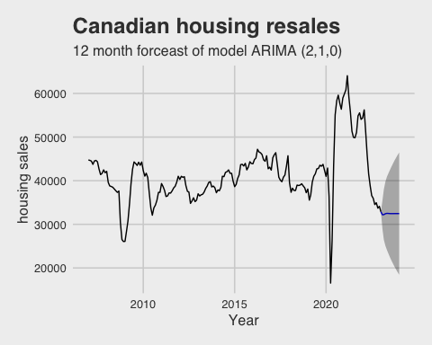

## Series: Can_month_housing_sell.ts   
## ARIMA(2,1,0)   
##   
## Coefficients:  
## ar1 ar2  
## 0.4457 -0.2715  
## s.e. 0.0693 0.0691  
##   
## sigma^2 = 6619935: log likelihood = -1779.31  
## AIC=3564.62 AICc=3564.75 BIC=3574.39

The conditional forecasting

What is the policy rate remain 4.5 for next 6 month? how it will impact the housing relae market what if the policy go back to 2019 levl at 1.75

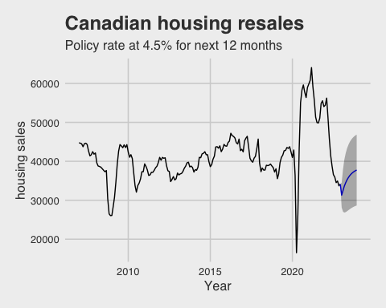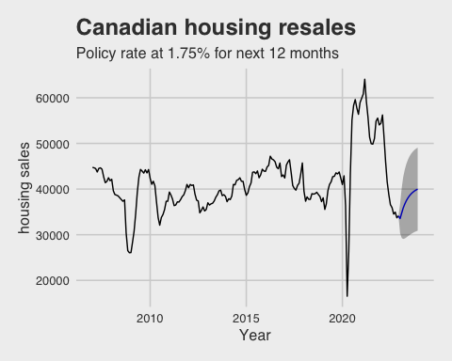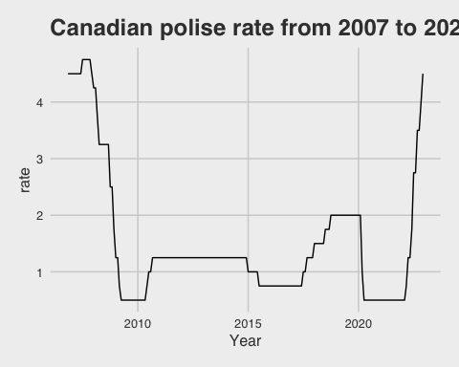

Part 2 VAR model

For better understand and forecasting the reltionahup between the canadian housing relase and other macro economic data relative to the business cycle. I contrucede model include the bank rate, gdp and infaltion and unmpleotymenr rate

The_evil_model <- VAR(all_data, p = 3 ,type = "const")

## $Granger  
##   
## Granger causality H0: stationary_CA_GDP.ts do not Granger-cause  
## stationary_Can_month_housing_sell.ts unemployment_rate.ts  
## Stationary_CPI.ts Bank_rate.ts  
##   
## data: VAR object The_evil_model  
## F-Test = 7.8983, df1 = 12, df2 = 805, p-value = 4.619e-14  
##   
##   
## $Instant  
##   
## H0: No instantaneous causality between: stationary_CA_GDP.ts and  
## stationary_Can_month_housing_sell.ts unemployment_rate.ts  
## Stationary_CPI.ts Bank_rate.ts  
##   
## data: VAR object The_evil_model  
## Chi-squared = 62.147, df = 4, p-value = 1.026e-12

## $Granger  
##   
## Granger causality H0: unemployment_rate.ts do not Granger-cause  
## stationary_Can_month_housing_sell.ts stationary_CA_GDP.ts  
## Stationary_CPI.ts Bank_rate.ts  
##   
## data: VAR object The_evil_model  
## F-Test = 0.94389, df1 = 12, df2 = 805, p-value = 0.5019  
##   
##   
## $Instant  
##   
## H0: No instantaneous causality between: unemployment_rate.ts and  
## stationary_Can_month_housing_sell.ts stationary_CA_GDP.ts  
## Stationary_CPI.ts Bank_rate.ts  
##   
## data: VAR object The_evil_model  
## Chi-squared = 36.519, df = 4, p-value = 2.262e-07

## $Granger  
##   
## Granger causality H0: Stationary_CPI.ts do not Granger-cause  
## stationary_Can_month_housing_sell.ts stationary_CA_GDP.ts  
## unemployment_rate.ts Bank_rate.ts  
##   
## data: VAR object The_evil_model  
## F-Test = 2.3884, df1 = 12, df2 = 805, p-value = 0.004937  
##   
##   
## $Instant  
##   
## H0: No instantaneous causality between: Stationary_CPI.ts and  
## stationary_Can_month_housing_sell.ts stationary_CA_GDP.ts  
## unemployment_rate.ts Bank_rate.ts  
##   
## data: VAR object The_evil_model  
## Chi-squared = 20.307, df = 4, p-value = 0.0004343

## $Granger  
##   
## Granger causality H0: Bank_rate.ts do not Granger-cause  
## stationary_Can_month_housing_sell.ts stationary_CA_GDP.ts  
## unemployment_rate.ts Stationary_CPI.ts  
##   
## data: VAR object The_evil_model  
## F-Test = 1.2761, df1 = 12, df2 = 805, p-value = 0.2274  
##   
##   
## $Instant  
##   
## H0: No instantaneous causality between: Bank_rate.ts and  
## stationary_Can_month_housing_sell.ts stationary_CA_GDP.ts  
## unemployment_rate.ts Stationary_CPI.ts  
##   
## data: VAR object The_evil_model  
## Chi-squared = 25.969, df = 4, p-value = 3.21e-05

interrdting enroughh that the unemploymetn rate has vey litter granfger causality test with the rest of data.

## [1] 0.9539947 0.9539947 0.9033594 0.8058010 0.6139851 0.6139851 0.5980735  
## [8] 0.5980735 0.5722210 0.5722210 0.4934902 0.4934902 0.4202403 0.2282110  
## [15] 0.0199506

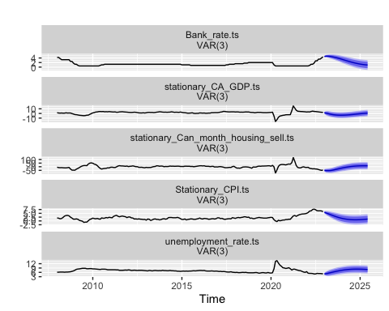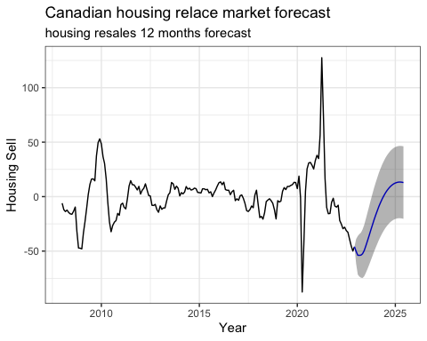

heel